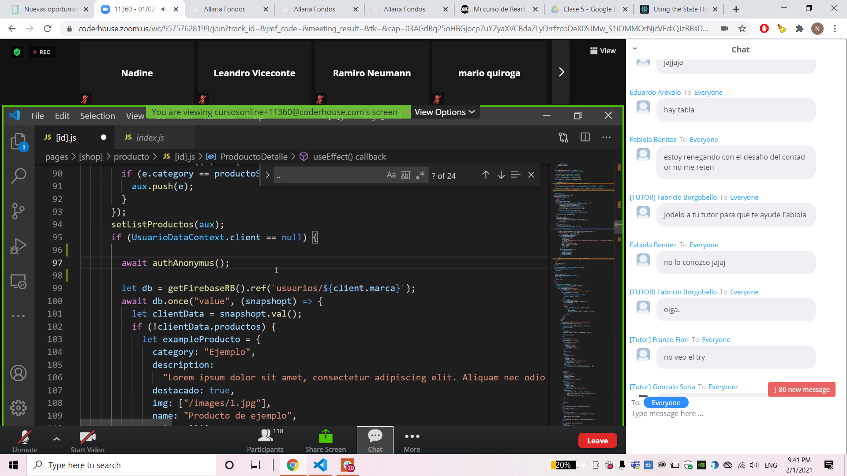

const promesa = new Promise ((resolve, reject) => { setTimeout( () => { resolve([ {id: 1, name: "zapas nike", description: "Zapas Air Force", stock: 3000 }, {id: 1, name: "Buzo Adidas", description: "Adidas linea Star Wars", stock: 1000 } ]) }, 3000); }); promesa.then( e => { console.log(e); })

